CSCI 321 Computer Science III Summer 2019

Lecture 3 Activity 2

1. Draw the binary tree representation of the following arithmetic expression: “(((5+2) ∗ (2−1))/((2+9)+((7−2)−1)) ∗8)”. Hint: Review the print arithmetic expression example on Chapter Slide 26.

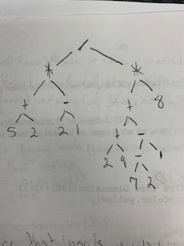

1. Give an O(n)-time algorithm for computing the depths of all nodes of a tree T, where n is the number of nodes of T. Write down the pseudocode. Hint: when you visit a node, you can perform some operation, for example, store some information in the node.

level = 0

do

{

i--

n = (n-1)/2

i = i%n

level++

}

while (i != 0)